Supplementary material
Figure S1. Projection interval for the cohort parameter for all available data and for all data except the first and last five birth cohort observations
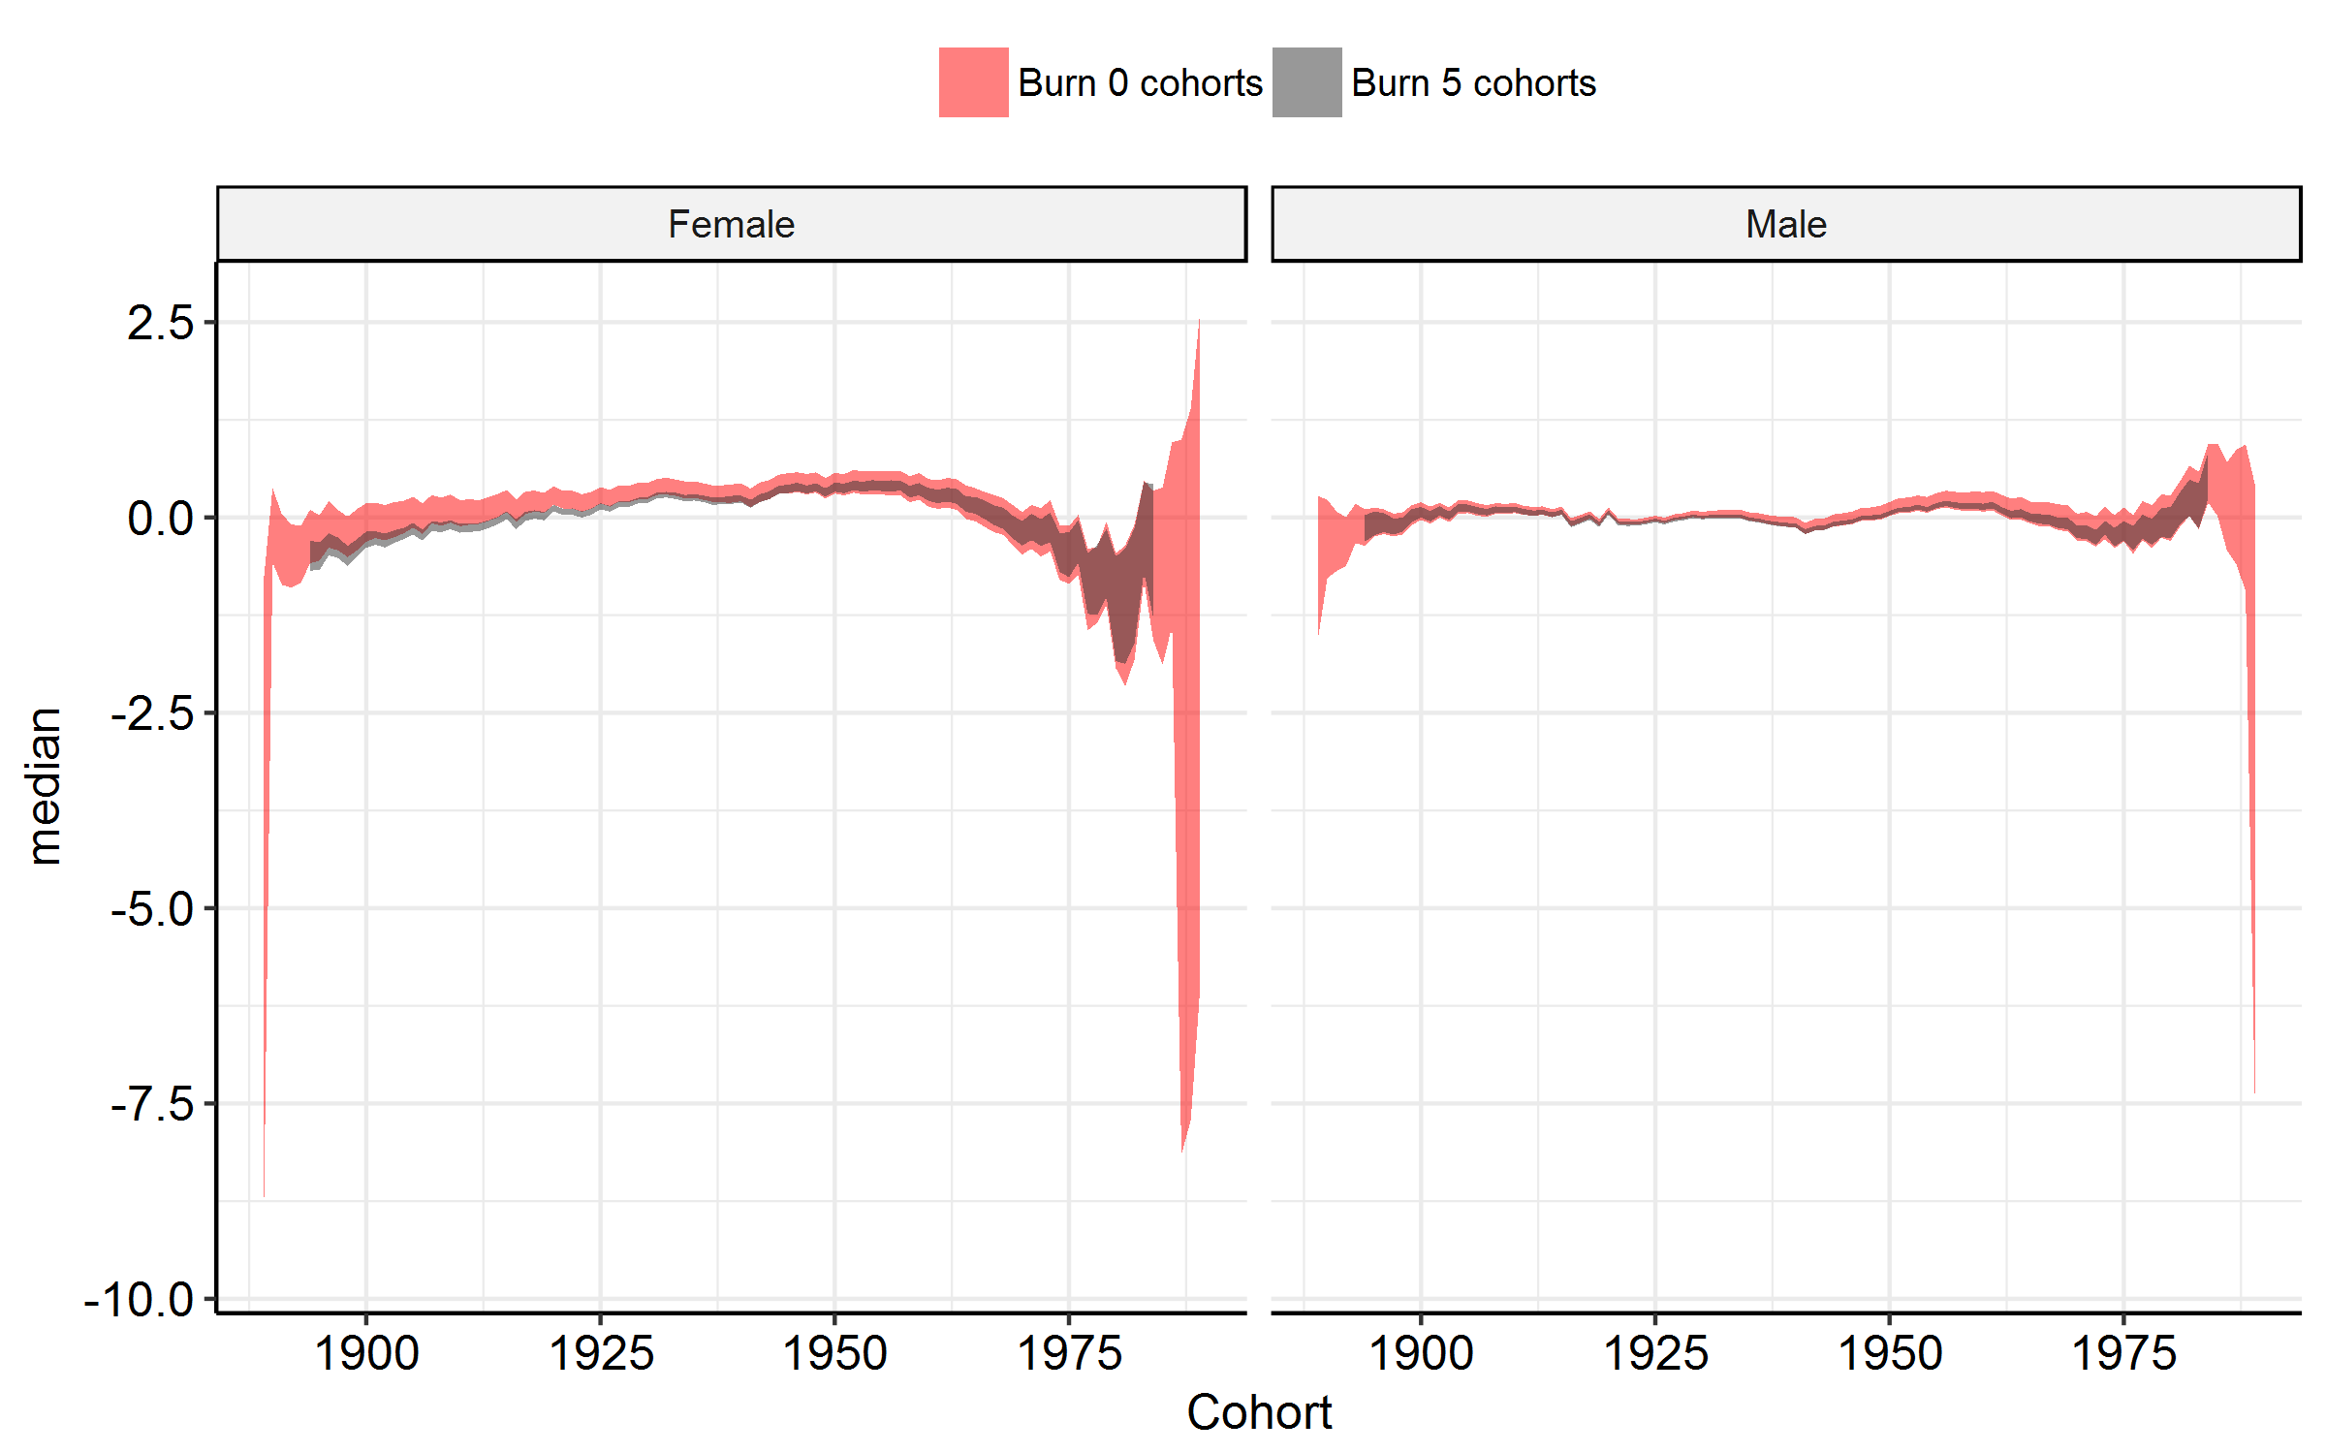
*We used bootstrapping to generate 500 resamples, and we re-estimated the models to estimate credible projection intervals.

Table S1. Projected age-standardized alcohol-attributable mortality rates (ages 25-90; per 100,000) in France, with 95% CI, by sex
 | Men |  |  | Women
Year | Baseline | Scenario I (period) | Scenario II (cohort) | Baseline | Scenario I (period) | Scenario II (cohort)
2015 | 32.6 (31.1-34.2) | 32.3 (30.7-33.9) | 32.7 (31.2-34.3) | 9.2 (8.6-9.9) | 9.2 (8.5-9.8) | 9.2 (8.6-9.9)
2016 | 31.9 (29.8-34.0) | 31.3 (29.1-33.6) | 32.0 (29.9-34.1) | 8.8 (8.0-9.7) | 8.7 (7.8-9.6) | 8.9 (8.0-9.8)
2017 | 31.2 (28.8-33.6) | 30.3 (27.7-33.0) | 31.4 (28.8-33.9) | 8.5 (7.5-9.6) | 8.3 (7.3-9.4) | 8.5 (7.5-9.6)
2018 | 30.5 (27.8-33.5) | 29.4 (26.4-32.5) | 30.7 (27.8-33.9) | 8.1 (7.1-9.3) | 7.8 (6.8-9.1) | 8.1 (7.1-9.4)
2019 | 29.8 (27.0-33.1) | 28.4 (25.3-31.7) | 30.0 (26.9-33.4) | 7.7 (6.6-9.0) | 7.4 (6.3-8.7) | 7.8 (6.7-9.1)
2020 | 29.2 (26.1-32.7) | 27.5 (24.3-31.1) | 29.3 (26.0-32.8) | 7.4 (6.3-8.7) | 7.0 (5.9-8.4) | 7.5 (6.3-8.8)
2021 | 28.4 (25.3-32.4) | 26.5 (23.1-30.5) | 28.8 (25.3-32.6) | 7.1 (5.9-8.4) | 6.6 (5.5-8.1) | 7.1 (6.0-8.5)
2022 | 27.8 (24.4-31.8) | 25.7 (22.1-29.5) | 28.1 (24.4-32.2) | 6.8 (5.6-8.2) | 6.2 (5.1-7.8) | 6.8 (5.6-8.2)
2023 | 27.2 (23.6-31.5) | 24.8 (21.3-28.8) | 27.6 (23.7-31.7) | 6.5 (5.3-7.9) | 5.9 (4.8-7.4) | 6.5 (5.4-7.9)
2024 | 26.6 (22.9-30.8) | 24.0 (20.2-28.1) | 27.0 (23.1-31.1) | 6.1 (4.9-7.7) | 5.6 (4.5-7.1) | 6.2 (5.1-7.6)
2025 | 25.9 (22.3-30.1) | 23.2 (19.5-27.3) | 26.5 (22.5-30.8) | 5.9 (4.7-7.3) | 5.3 (4.2-6.7) | 6.0 (4.8-7.4)
2026 | 25.3 (21.7-29.5) | 22.5 (18.7-26.8) | 26.0 (21.7-30.2) | 5.6 (4.4-7.0) | 5.0 (3.9-6.3) | 5.7 (4.6-7.0)
2027 | 24.7 (21.0-29.2) | 21.8 (18.0-26.1) | 25.6 (21.1-29.9) | 5.3 (4.2-6.7) | 4.7 (3.6-6.1) | 5.5 (4.2-6.8)
2028 | 24.1 (20.3-28.9) | 21.0 (17.3-25.4) | 25.1 (20.7-29.7) | 5.0 (3.9-6.5) | 4.4 (3.4-5.8) | 5.2 (4.0-6.5)
2029 | 23.7 (19.7-28.2) | 20.4 (16.5-24.9) | 24.7 (20.1-29.2) | 4.8 (3.7-6.2) | 4.2 (3.1-5.4) | 4.9 (3.8-6.3)
2030 | 23.1 (19.1-27.8) | 19.6 (16.0-24.4) | 24.2 (19.6-28.8) | 4.5 (3.5-6.0) | 3.9 (2.9-5.1) | 4.7 (3.6-6.1)
2031 | 22.6 (18.6-27.7) | 18.9 (15.4-23.7) | 23.8 (19.2-28.6) | 4.3 (3.2-5.7) | 3.7 (2.7-4.9) | 4.5 (3.4-5.8)
2032 | 22.0 (18.2-26.8) | 18.4 (14.8-22.7) | 23.5 (18.8-28.3) | 4.1 (3.0-5.5) | 3.5 (2.5-4.7) | 4.3 (3.2-5.6)
2033 | 21.5 (17.6-26.3) | 17.8 (14.4-22.2) | 23.0 (18.1-27.8) | 3.9 (2.9-5.2) | 3.2 (2.4-4.4) | 4.1 (3.0-5.4)
2034 | 21.1 (17.0-26.0) | 17.2 (13.9-21.6) | 22.7 (17.9-27.7) | 3.7 (2.7-5.1) | 3.1 (2.2-4.1) | 3.9 (2.8-5.2)
2035 | 20.6 (16.6-25.8) | 16.7 (13.3-21.2) | 22.3 (17.5-27.5) | 3.5 (2.5-4.9) | 2.9 (2.0-3.9) | 3.7 (2.7-5.0)
2036 | 20.2 (16.1-25.4) | 16.2 (12.7-20.4) | 22.0 (17.1-27.1) | 3.3 (2.4-4.6) | 2.7 (1.9-3.7) | 3.5 (2.5-4.9)
2037 | 19.6 (15.7-24.8) | 15.7 (12.4-20.1) | 21.7 (16.7-26.9) | 3.1 (2.2-4.4) | 2.5 (1.8-3.5) | 3.3 (2.4-4.6)
2038 | 19.3 (15.2-24.3) | 15.2 (12.0-19.4) | 21.3 (16.7-27.0) | 3.0 (2.1-4.2) | 2.4 (1.6-3.3) | 3.2 (2.3-4.5)
2039 | 18.9 (14.8-24.0) | 14.7 (11.6-19.0) | 21.0 (16.4-26.7) | 2.8 (2.0-3.9) | 2.2 (1.5-3.1) | 3.0 (2.2-4.3)
2040 | 18.5 (14.4-23.5) | 14.3 (11.1-18.7) | 20.6 (15.9-26.6) | 2.6 (1.9-3.8) | 2.1 (1.4-3.0) | 2.9 (2.1-4.1)

Figure S2. Projected age-standardized alcohol-attributable mortality rates in France (long-term trends up to 2100), by sex
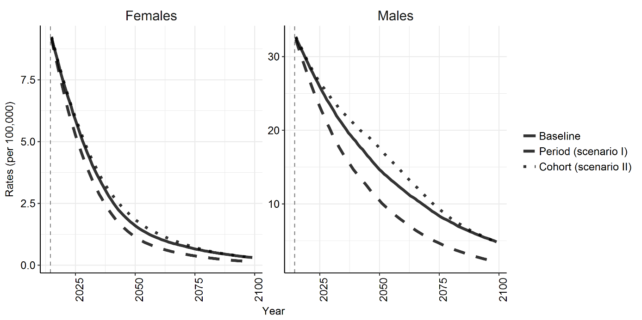

Figure S3. Comparison of projected age-standardized alcohol-attributable mortality rates (per 100,000) in France (2015-2040) with rates from other European countries in 2014
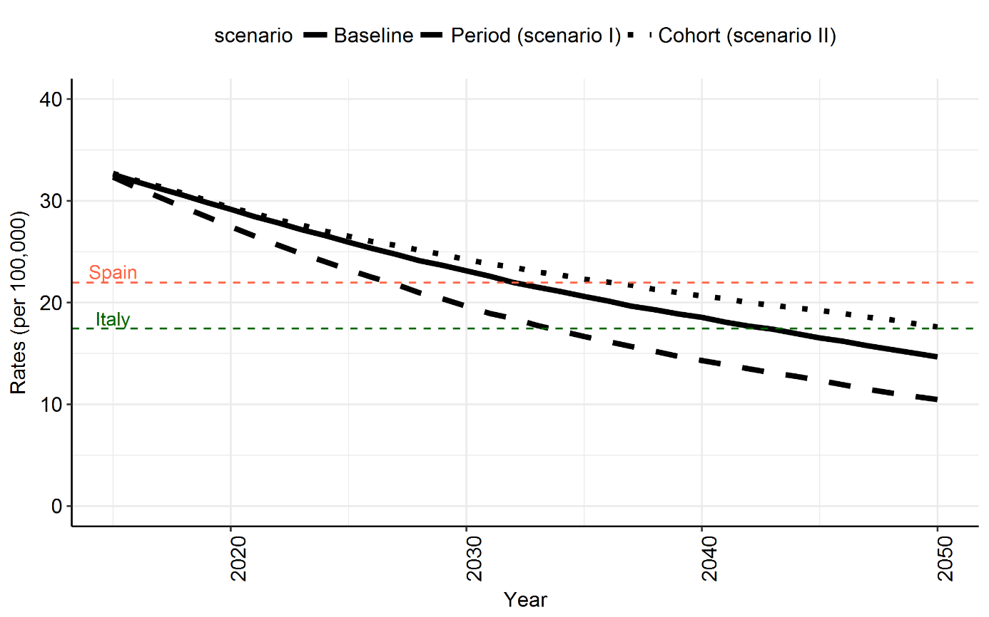

* Own estimates based on our own projection and on data from the WHO Mortality Database for countries other than France for the age group 25-89.

Figure S4. Observed (2014) and projected (2025, 2040, 2050, 2075, 2100) age-specific alcohol-attributable mortality rates (25-90) in France, by sex
